If your friend or a recruiter downloads your project, they will run jooq-codegen:generate on their own computer anyway. If you uploaded your copies to GitHub, their computer will try to generate them again, creating duplicate file errors and causing the Java compiler to crash.

Setting up Database:
1.Install postgressql with password = postgres and username is also postgres defaultly
2.pgadmin 4 is the search icon to open the database
3.Inside database create a new server with localhost (127.0.0.1) and port = 5432
4.this above values used in intelliz java code to setup
Setting the pom dependencies and build
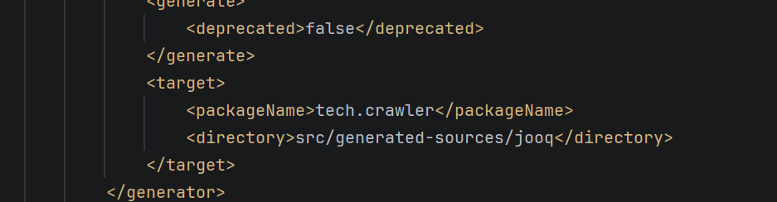
This will create the folder inside src -> generated-sources ->jooq when builded up for the first time and the tables created in jooq comes here as .java
The password and url should match our database:
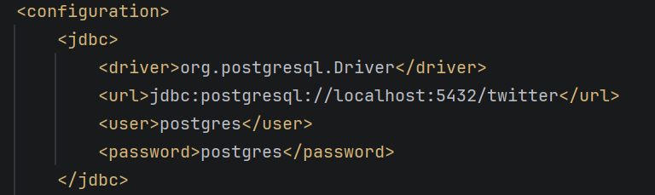

Run Maven->plugins->jooq-codegen:generate: (to update table from database to jooq)
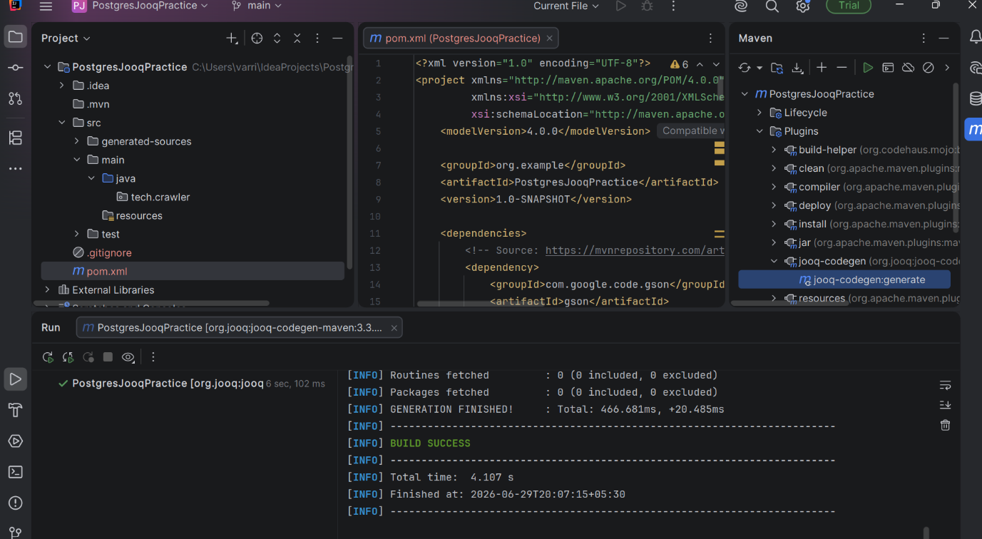

The tables created came into our directory src->generated-sources ->jooq:
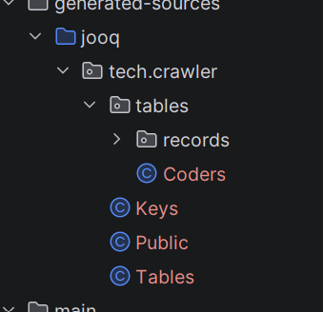

We have GenericDB class which uses DatabaseConnectionPool and DatabaseUtil which uses our twitter database

GenericDB uses those two classes and we have methods (ctrl+fn+f12)
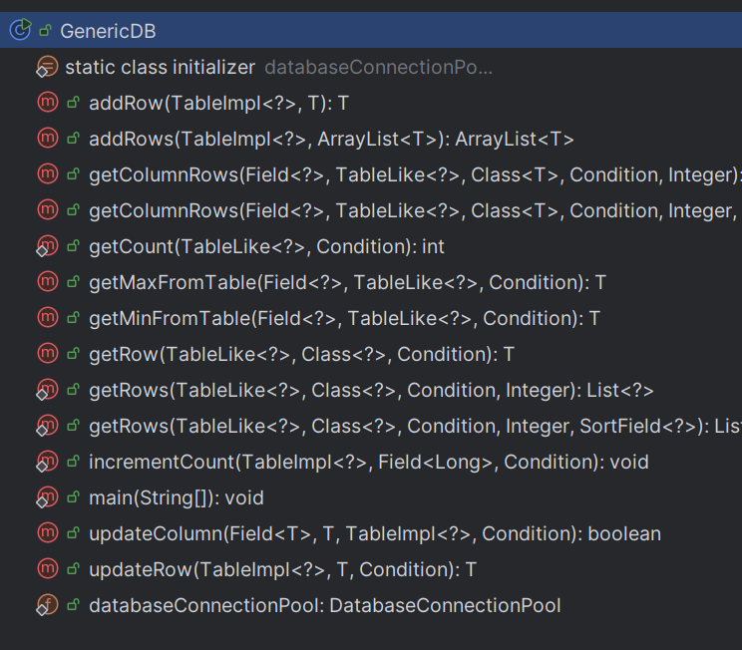

Created Coders.java class with the same attributes with a constructor and getmethods

Then TestCodersTable.java

Which calls ,
Coders coder = new Coders(“varri yaswanth”,24);
new GenericDB<Coders>().addRow(tech.crawler.tables.Coders.CODERS,coder)
Run jooq-codegen:generate ONLY when:
- You create a brand new table in pgAdmin (e.g., when you create a wiki_pages table later).
- You alter an existing table (e.g., adding a new column like image_url or changing a column's data type).
- You delete (drop) a table completely from your database.
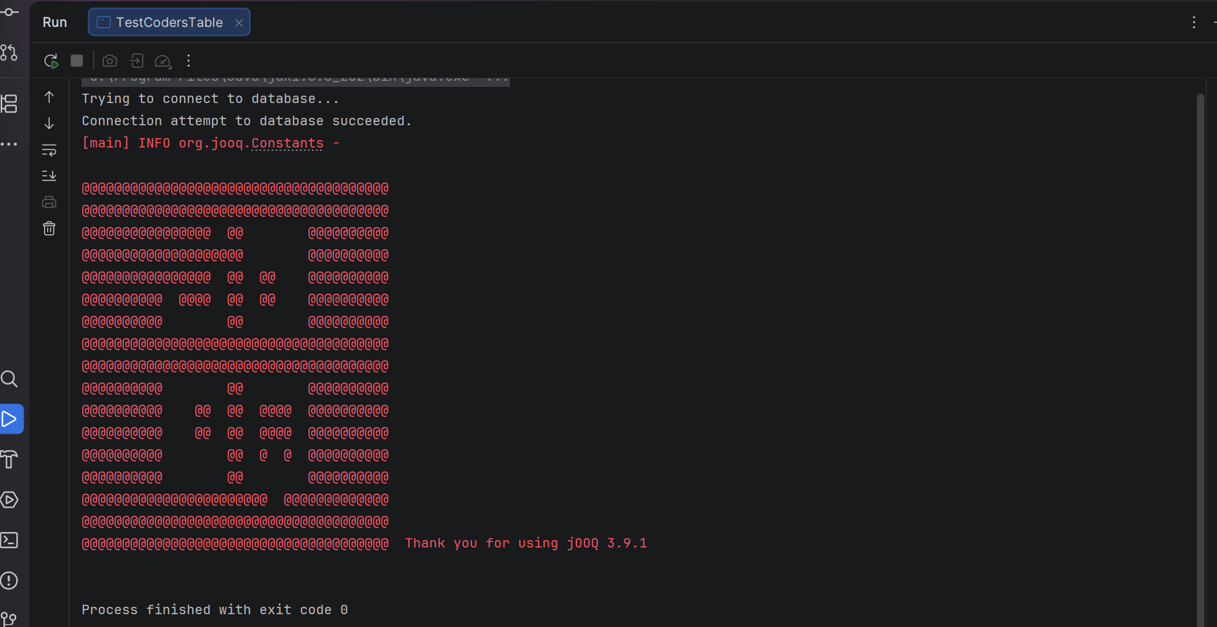

Data passed to table:
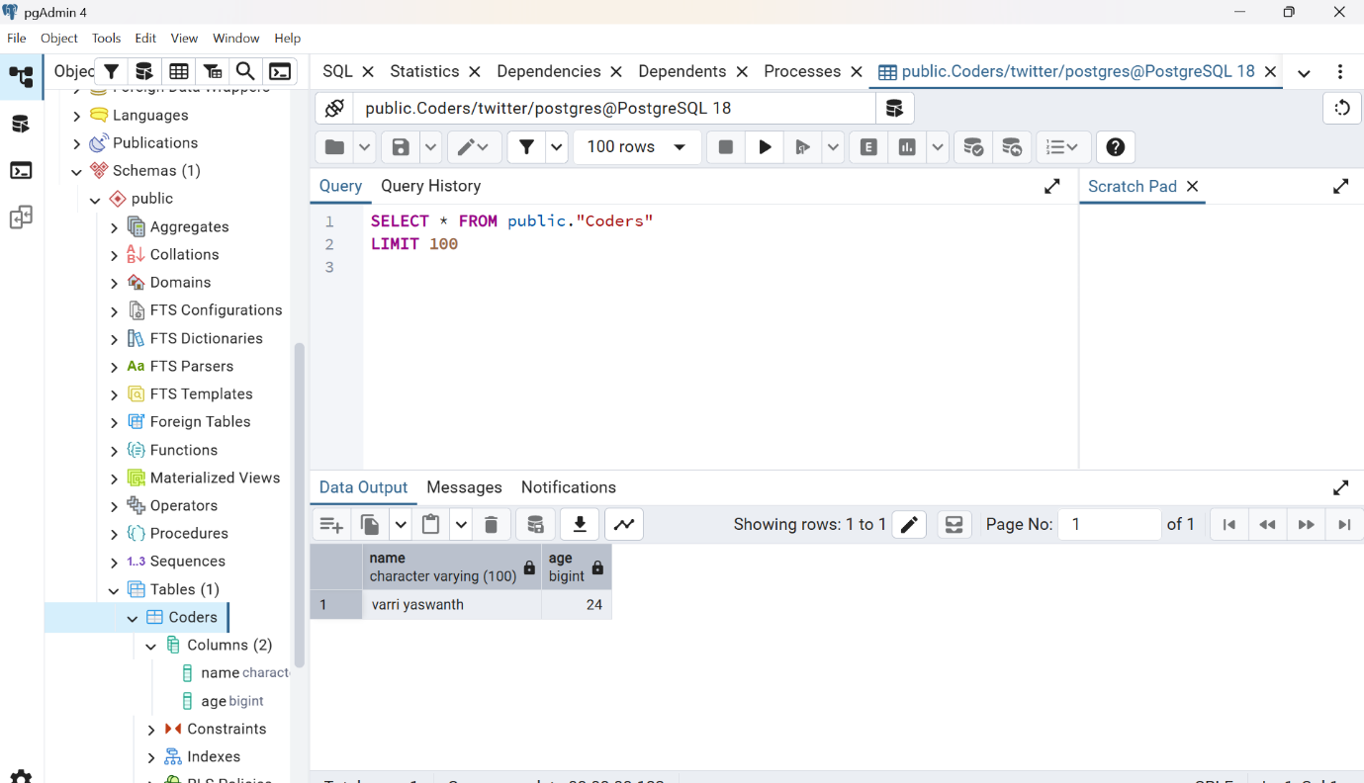

Added Spammer: 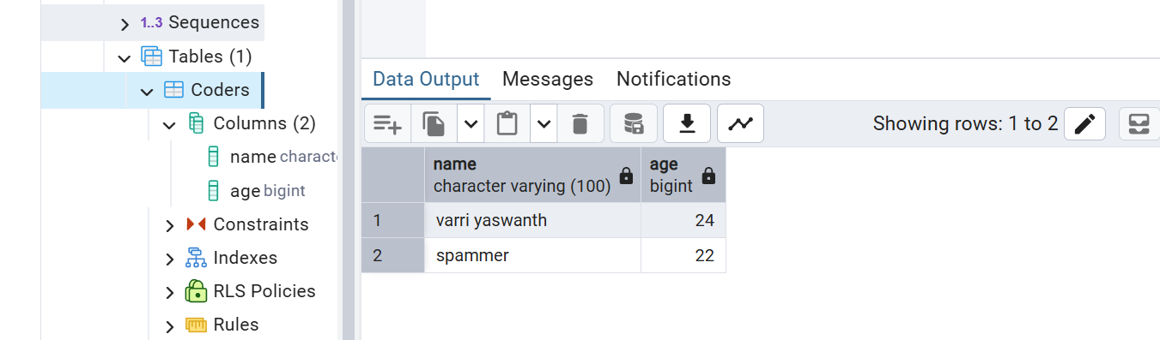

Replacing Spammer with Sadie Varri:
new GenericDB<String>().updateColumn(tech.crawler.tables.Coders.CODERS.NAME,"Sadie Varri", tech.crawler.tables.Coders.CODERS, tech.crawler.tables.Coders.CODERS.NAME.eq("spammer"));
